Salmon en Papillote with Fennel, Green Beans, Orange and Pink Peppercorns

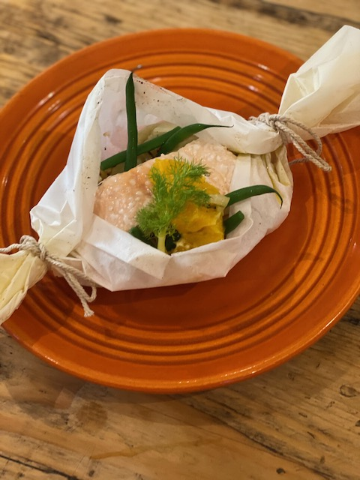

Salmon is a great source of protein and is packed with Omega-3 Fatty Acids, which are important for cardiovascular health. The fennel is full of fibre, the oranges are a good source of Vitamin C and the red onions are high in heart-healthy resveratrol. This dish can be prepared in advance and then cooked without the fuss of cooking additional vegetables at the last minute.

Ingredients (for one):

A Sheet of Greaseproof Paper or Silicone Paper (45cm long) and string

150g Salmon Fillet
1 Orange (peeled and cut into 4 slices)
¼ Head of Fennel
50g Fine Green Beans
Half Small Red Onion
A small amount of butter for greasing
Sea Salt to taste
A Sprinkle Pink Peppercorns in brine (optional)
Tbsp Extra Virgin Olive Oil

Set the oven to 180 Deg C.

Fold the greaseproof paper in half and grease the middle with a little butter.

Slice the red onion and the fennel finely and sweat in the olive oil for 5 minutes until slightly softened. Season to taste with sea salt and black pepper.

Blanch the beans in boiling water for 3-4 of minutes and then plunge into very cold water to maintain the colour.

Place 3 of the slices of orange into the middle of the greaseproof paper lengthways. Then add the onion, fennel and beans. Place the salmon on top of this, add the last slice of orange and sprinkle with pink peppercorns if desired. Season again with salt and then fold the paper up to make a parcel. I like to tie mine up into a cracker shape, but you can fold it if you prefer. The important thing is to make sure it is leak-proof at the bottom.

Place in the oven and cook for 10 – 15 minutes until the salmon is cooked.

